

Windows Installer Instructions

Step 1: Point your browser at the cypress github [download](https://github.com/projectcypress/cypress/downloads) page and save the file to your local machine.

File: [popHealth-x86_64.exe](https://xfiles.mitre.org/seos/1000/mpd/1201201235e26aa30bfa0f8f0f6e15100dc3188a), 80,978.70 KB     
File: [popHealth-i386.exe](https://xfiles.mitre.org/seos/1000/mpd/1201201207fec67387d44062d497f595f437d05d), 78,398.88 KB

Step 2: Double-click the installer executable file of your choosing. Respond “Yes” when the User Account Control dialog appears.

Step 3: Click the “Next” button when the cypress Setup Wizard opens

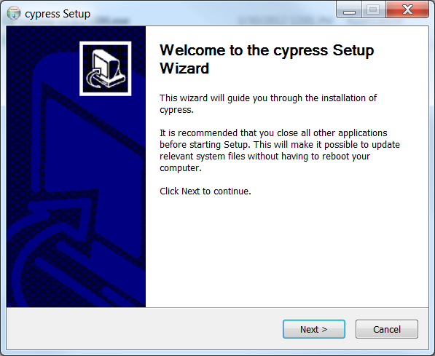

Step 4: Click the check box next to “I accept” and then click the “Next” button

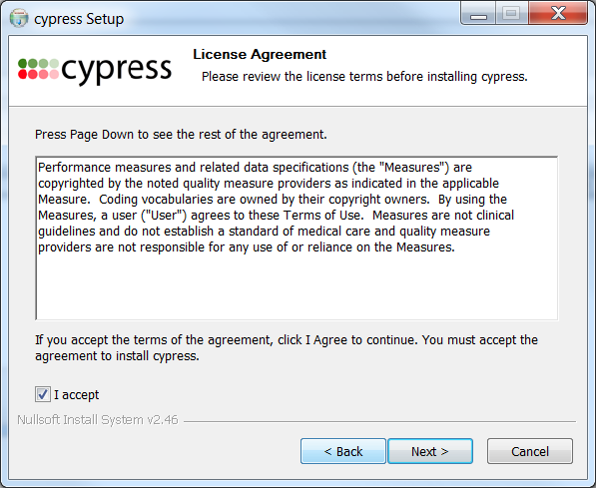

Step 5: Click the “Next” button. Unless you have a very good reason to do otherwise, and you know what you’re doing, leave all of the optional components selected.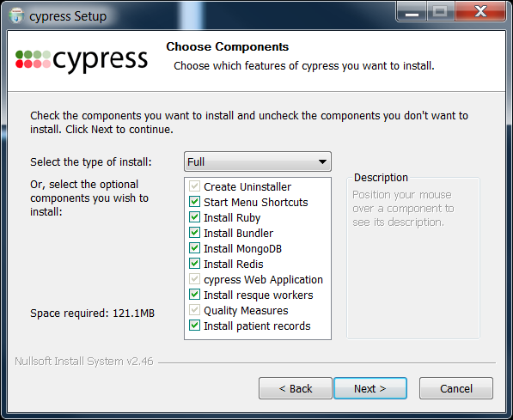

Step 6: Click the “Next” button.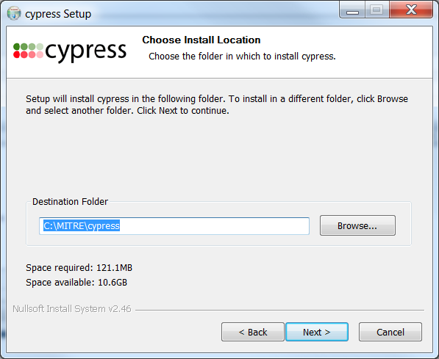

Step 7: Check the “Use Proxy Server” box. Depending on where you are installing the software you will type in the following information:

* MITRE employees in Bedford: type **gatekeeper.mitre.org** in the server text box and **80** in the port text box
* MITRE employees in Washington: type **gatekeeper-w.mitre.org** in the server text box and **80** in the port text box
* If you are installing this else where you will have to get this information from a network administrator.

Then click the “Install” button

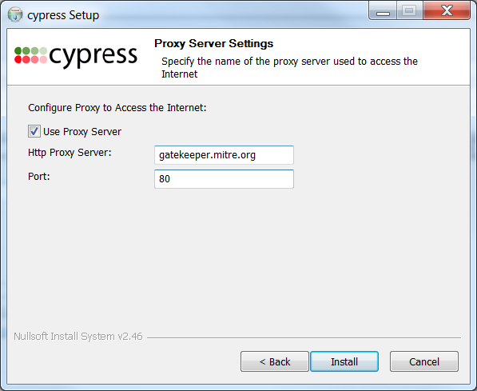

Step 8: Click to either “Reboot now” or “Manually reboot later” and then click the “Finish” button

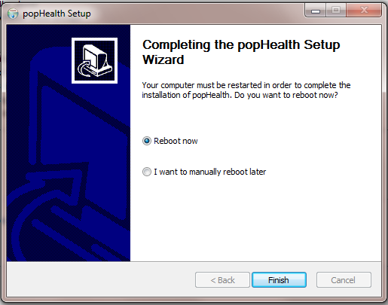

After rebooting your system you can go to the Start Menu and find the cypress folder. There will be two items in the folder. One is a shortcut to the cypress login on your web browser.

You can uninstall the program by either selecting the uninstall item in the cypress folder or by going to the Control Panel, selecting add/remove programs, selecting the cypress application and then click on the uninstall button at the top of the list of applications.